The Gospel of Mark:
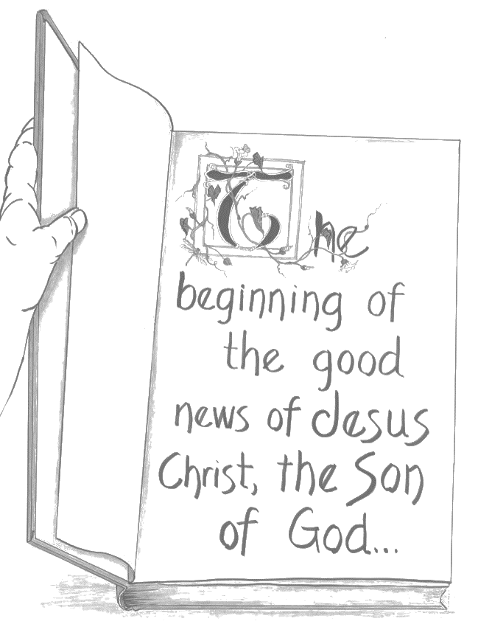
The NeverEnding Story Chapter 16

ELCA Book of Faith Initiative
National Youth Gathering 2015

images by Janelle Thompson amadcatstudio@me.com
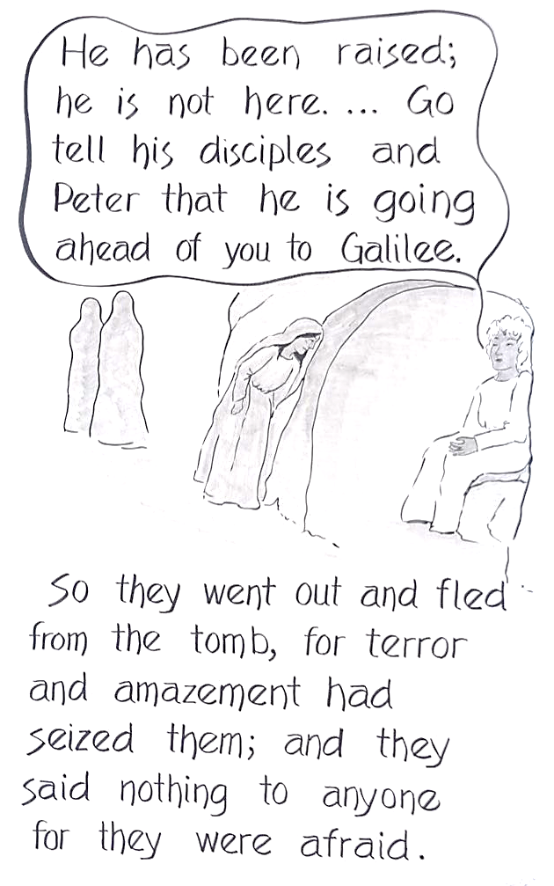
Mark 16:1-8
